Project Design Phase-II
Project Design Phase Solution Architecture

Data Science Project Documentation

Submitted By: Uma Maheswari (TL) | Date: 15

July 2026

Technology Stack (Architecture & Stack)

Team | G Hema Sree  Perugu Uma Maheswari  Nikitha Palyam  Kc Jahnavi  Athika Athika
Project Name | Strategic product placement analysis: unveiling sales impact with tableau visualization

Technical Architecture:

Data Sources:
Integrates unstructured planograms/calendars from Cloud Storage (Google Drive) with structured POS/inventory data from Database Servers.

Preparation:
Uses Tableau to clean SKU inconsistencies and join "Placement" metadata with actual "Sales" figures.

Analytics Engine:
A core modeling layer that calculates specific KPIs like Eye-Level Lift and End-Cap Conversion Rates.

Distribution:
Hosted on Tableau Server/Cloud for security and automated data refreshes.

Accessibility:
Features a Responsive Design optimized for mobile, tablet, and desktop viewing.

User Action:
Enables Category Managers to make rapid "Keep or Move" decisions based on real-time impact visualization.
Core Impact Metrics

To keep the analysis focused, the system prioritizes these three high-level views:

Placement ROI:
Sales growth vs. the cost of premium shelf space.

Heatmap Analysis:
Visualizing "Hot Zones" vs. "Dead Zones" within a store aisle.
A/B Testing:
Direct comparison of sales performance across two different placement strategies

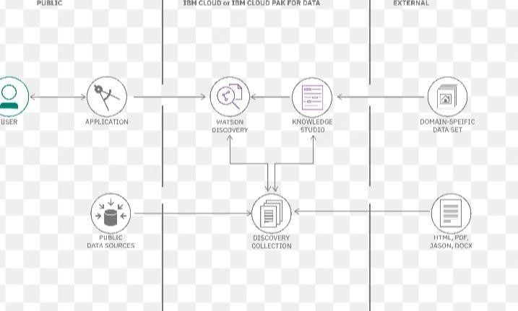

Table-1 : Components & Technologies:

S.No | Component | Description | Technology
1. | User Interface | Responsive Web and Mobile UI for interactive dashboard viewing. | Tableau Web / Mobile App
2. | Application Logic-1 | Data harmonization and ETL to merge planograms with sales data. | Tableau Prep / Python
3. | Application Logic-2 | Impact modeling to calculate Eye-level vs. | Bottom-shelf sales lift. Tableau Desktop / SQL
4. | Application Logic-3 | Automated refresh scheduling for real-time sales trend | Tableau Server Scheduler
 |  | monitoring.
5. | Database | Stores structured historical POS transactions and store metadata. | MySQL /  PostgreSQL
6. | Cloud Database | High-speed warehouse for aggregating multi-store retail datasets. | Snowflake / Google BigQuery
7. | File Storage | Storage for flat-file planograms and manual store audit logs. | Google Drive / Local Filesystem
8. | External API-1 | Normalizes sales data based on local weather or seasonal trends. | IBM Weather API
9. | External API-2 | Automates user permission syncing and programmatic report delivery. | Tableau REST API
10. | Machine Learning | Forecasts potential  revenue lift for proposed shelf-space changes. | Python (Scikit-learn)
11. | Infrastructure | Secure cloud deployment for 24/7 multi-device accessibility. | Tableau Cloud / Kubernetes

Table-2: Application Characteristics:

S.No | Characteristics | Description | Technology
1. | Open-Source Frameworks | Utilizing open-source tools for data  transformation and | Python  (Pandas/NumPy),  PostgreSQL,  Open-source API
 |  | visualization agility. | connectors
2. | Security  Implementations | Multi-layered security with Row-Level Security  (RLS) and encrypted data transit. | SHA-256,  SAML/SSO, Tableau  RLS, SSL/TLS Encryption.
3. | Scalable  Architecture | A 3-tier architecture  (Data, Logic, Presentation) designed for multi-device growth. | Micro-services,  Kubernetes, Tableau Cloud Clusters.
4. | Availability | High availability through distributed servers and automated health checks. | Load Balancers,  AWS Multi-AZ, Tableau Server High  Availability.
5 | Performance | Optimized query execution through data extracts and caching for fast load times. | Redis Caching,  Tableau Data Hyper Extracts, CDN (CloudFront).

